Geometry Deductive Reasoning

Definition
# Source: AI Source: Provided by: [Data Path: Persons Table -> ID Column: 1, Name_En Column: Motasem Essam] -> From: [ChatGPT] on [7/25/2026]
Geometry Deductive Reasoning is the process of using known geometric facts, definitions, axioms, postulates, theorems, and logical rules to derive conclusions that must be true.
It moves from general principles and known information to a specific, logically necessary conclusion.
$$\boxed{\text{Known Facts}→\text{Logical Rules}→\text{Derived Facts}→\text{Conclusion}}$$
Unlike visual observation or measurement, deductive reasoning establishes mathematical certainty.

Simple Definition
# Source: AI Source: Provided by: [Data Path: Persons Table -> ID Column: 1, Name_En Column: Motasem Essam] -> From: [ChatGPT] on [7/25/2026]
Geometry Deductive Reasoning means using what is already known to logically prove what must be true about a geometric figure.
Example
Given:
$$AB=AC$$
in $△ABC$.
Since two sides are equal, the triangle is isosceles. Therefore, its opposite base angles are equal:
$$\boxed{∠B=∠C}$$
The conclusion follows necessarily from the given information and a known theorem.

Fundamental Concept
# Source: AI Source: Provided by: [Data Path: Persons Table -> ID Column: 1, Name_En Column: Motasem Essam] -> From: [ChatGPT] on [7/25/2026]
Deductive reasoning in geometry follows a logical chain:
Given Information
↓
Definitions / Axioms / Postulates
↓
Known Theorems
↓
Logical Deduction
↓
New Geometric Facts
↓
Required Conclusion
Each step must be justified.
A geometric statement is not considered proven merely because:
- it looks correct in a diagram,
- it works in one example,
- a measurement appears to confirm it,
- or a calculator produces the expected value.
The conclusion must follow logically from accepted mathematical facts.

Main Components

1. Given Information
# Source: AI Source: Provided by: [Data Path: Persons Table -> ID Column: 1, Name_En Column: Motasem Essam] -> From: [ChatGPT] on [7/25/2026]
The given consists of facts provided by the problem.
Examples:
$$AB=AC \\ AB∥CD \\ ∠A={90}^{∘} \\ M\text{ is the midpoint of }\overset{‾}{AB}$$
The given information is the starting point of the reasoning process.

2. Definitions
# Source: AI Source: Provided by: [Data Path: Persons Table -> ID Column: 1, Name_En Column: Motasem Essam] -> From: [ChatGPT] on [7/25/2026]
Definitions establish the exact meaning of geometric terms.
Examples:
Midpoint
If $M$is the midpoint of $\overset{‾}{AB}$:
$$AM=MB$$
and $A,M,B$are collinear.
Perpendicular Lines
If
$$l_{1}⊥l_{2}$$
then they intersect at a right angle:
$${90}^{∘}$$
Parallel Lines
If
$$l_{1}∥l_{2}$$
then the lines lie in the same plane and do not intersect.
Angle Bisector
If ray $BD$bisects $∠ABC$:
$$∠ABD=∠DBC$$
Definitions can therefore be used directly as reasons in a proof.

3. Axioms and Postulates
# Source: AI Source: Provided by: [Data Path: Persons Table -> ID Column: 1, Name_En Column: Motasem Essam] -> From: [ChatGPT] on [7/25/2026]
Axioms and postulates are fundamental statements accepted without proof within the mathematical system.
Examples include:
- Through two distinct points, exactly one line can be drawn.
- A segment can be extended indefinitely.
- All right angles are congruent.
- A circle can be constructed with any center and radius.
They provide foundations from which geometric conclusions can be derived.

4. Theorems
# Source: AI Source: Provided by: [Data Path: Persons Table -> ID Column: 1, Name_En Column: Motasem Essam] -> From: [ChatGPT] on [7/25/2026]
A theorem is a statement that has already been established by proof and can therefore be used to prove other statements.
Examples:
- Vertical Angles Theorem
- Triangle Sum Theorem
- Isosceles Triangle Theorem
- Pythagorean Theorem
- Perpendicular Bisector Theorem
- Angle Bisector Theorem
- Triangle Congruence Theorems
- Triangle Similarity Theorems
A theorem can become a reason in a later deductive proof.

5. Logical Rules
# Source: AI Source: Provided by: [Data Path: Persons Table -> ID Column: 1, Name_En Column: Motasem Essam] -> From: [ChatGPT] on [7/25/2026]
Deductive reasoning also depends on rules of logic.
Transitive Property
If
$$a=b$$
and
$$b=c$$
then
$$a=c$$
Substitution Property
If
$$a=b$$
then $b$can replace $a$in an equation or statement.
Reflexive Property
Every quantity is equal to itself:
$$a=a$$
Symmetric Property
If
$$a=b$$
then
$$b=a$$
These rules allow individual facts to be connected into a valid chain of reasoning.

Types of Deductive Reasoning in Geometry
# Source: AI Source: Provided by: [Data Path: Persons Table -> ID Column: 1, Name_En Column: Motasem Essam] -> From: [ChatGPT] on [7/25/2026]
The main logical forms used in geometry can be organized as follows:
Geometry Deductive Reasoning
├── Direct Deductive Reasoning
├── Conditional Reasoning
├── Proof by Contradiction
├── Proof by Contrapositive
└── Proof by Cases
These are logical methods. They should be distinguished from proof presentation formats such as two-column, paragraph, and flow proofs.

1. Direct Deductive Reasoning
# Source: AI Source: Provided by: [Data Path: Persons Table -> ID Column: 1, Name_En Column: Motasem Essam] -> From: [ChatGPT] on [7/25/2026]
Definition
Direct Deductive Reasoning is a method in which the proof begins with the given information and uses definitions, postulates, theorems, and logical rules to proceed directly toward the required conclusion.
The basic structure is:
$$\boxed{\text{Given}→\text{Known Facts}→\text{Logical Deductions}→\text{Conclusion}}$$
The conclusion is obtained without assuming its opposite.
General Structure
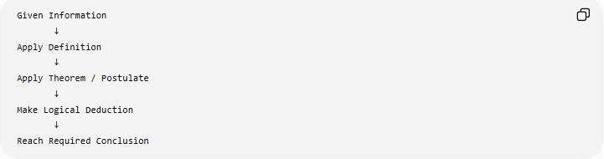
Given Information
↓
Apply Definition
↓
Apply Theorem / Postulate
↓
Make Logical Deduction
↓
Reach Required Conclusion
Example 1: Isosceles Triangle
Given:
$$AB=AC$$
in $△ABC$.
Prove:
$$∠B=∠C$$
Reasoning
- $AB=AC$— Given.
- $△ABC$is an isosceles triangle — Definition of an isosceles triangle.
- The angles opposite equal sides of an isosceles triangle are congruent — Isosceles Triangle Theorem.
- Therefore:
$$\boxed{∠B=∠C}$$
This is direct reasoning because every step moves directly from the given information toward the conclusion.
Example 2: Perpendicular Lines
Given:
$$l_{1}⊥l_{2}$$
Prove:
The angle formed by the two lines is ${90}^{∘}$.
Since perpendicular lines intersect at a right angle:
$$l_{1}⊥l_{2}$$
implies:
$$\boxed{∠={90}^{∘}}$$

2. Conditional Reasoning
# Source: AI Source: Provided by: [Data Path: Persons Table -> ID Column: 1, Name_En Column: Motasem Essam] -> From: [ChatGPT] on [7/25/2026]
Definition
Conditional Reasoning uses a conditional statement of the form:
$$\boxed{P→Q}$$
which means:
If $P$is true, then $Q$must be true.
In geometry, conditional reasoning is useful for connecting a geometric condition with a necessary consequence.
General Structure
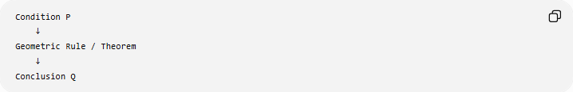
Condition P
↓
Geometric Rule / Theorem
↓
Conclusion Q
Example 1: Perpendicular Lines
Consider:
If two lines are perpendicular, then they form right angles.
Let:
$$P=\text{the two lines are perpendicular}$$
and
$$Q=\text{they form right angles}$$
Then:
$$\boxed{P→Q}$$
Therefore:
$$l_{1}⊥l_{2}$$
implies:
$$\boxed{∠={90}^{∘}}$$
Example 2: Isosceles Triangle
Conditional statement:
If two sides of a triangle are congruent, then the angles opposite those sides are congruent.
Symbolically:
$$AB=AC \\ ⇓ \\ \boxed{∠B=∠C}$$
The equality of the sides is the condition, and equality of the opposite angles is the consequence.
Important Note
Conditional reasoning is not necessarily a completely separate proof structure from direct reasoning. A conditional statement can be established using a direct proof, contradiction, or another logical method.

3. Proof by Contradiction
# Source: AI Source: Provided by: [Data Path: Persons Table -> ID Column: 1, Name_En Column: Motasem Essam] -> From: [ChatGPT] on [7/25/2026]
Definition
Proof by Contradiction is a deductive method in which the opposite of the desired conclusion is temporarily assumed. The assumption is then shown to lead to a contradiction.
The contradiction demonstrates that the assumption must be false, so the original conclusion must be true.
General Structure
$$\boxed{\text{Assume }¬P→\text{Logical Deductions}→\text{Contradiction}→P}$$
Here:
- $P$= desired conclusion
- $¬P$= negation of the conclusion
- $⊥$= contradiction
Therefore:
$$\boxed{¬P→⊥⇒P}$$
Example: Two Lines Perpendicular to the Same Line
Suppose:
$$l_{1}⊥m$$
and
$$l_{2}⊥m$$
We want to establish that:
$$l_{1}∥l_{2}$$
Contradiction Approach
Assume the opposite:
$$l_{1}∦l_{2}$$
Then the two lines must intersect at some point.
Because both $l_{1}$and $l_{2}$are perpendicular to $m$, each forms a ${90}^{∘}$angle with $m$.
In a Euclidean plane, through a given point there is exactly one line perpendicular to a given line. Therefore, the two lines cannot be distinct intersecting lines both perpendicular to $m$.
This contradicts the assumption that they intersect.
Therefore:
$$\boxed{l_{1}∥l_{2}}$$
Structure
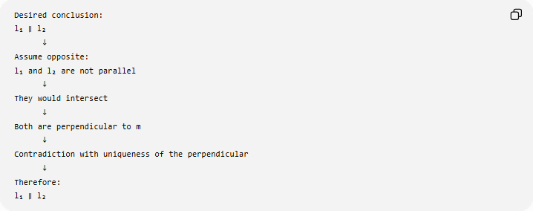
Desired conclusion:
l₁ ∥ l₂
↓
Assume opposite:
l₁ and l₂ are not parallel
↓
They would intersect
↓
Both are perpendicular to m
↓
Contradiction with uniqueness of the perpendicular
↓
Therefore:
l₁ ∥ l₂
When It Is Useful
Proof by contradiction is particularly useful when:
- the opposite assumption creates an obvious conflict,
- direct reasoning is inconvenient,
- the geometry involves impossibility,
- a uniqueness property can be used,
- the statement involves "there cannot be..." or "must be...".

4. Proof by Contrapositive
# Source: AI Source: Provided by: [Data Path: Persons Table -> ID Column: 1, Name_En Column: Motasem Essam] -> From: [ChatGPT] on [7/25/2026]
Definition
Proof by Contrapositive proves a conditional statement by proving its logically equivalent contrapositive.
For the conditional:
$$\boxed{P→Q}$$
the contrapositive is:
$$\boxed{¬Q→¬P}$$
These two statements are logically equivalent:
$$\boxed{P→Q ⟺ ¬Q→¬P}$$
Therefore, proving the contrapositive establishes the original conditional.

Example: Isosceles Triangle
Consider the theorem:
If two angles of a triangle are not congruent, then the sides opposite those angles are not congruent.
The direct form can be written:
$$∠B≠∠C→AC≠AB$$
Its contrapositive is:
$$AB=AC→∠B=∠C$$
The contrapositive follows from the Isosceles Triangle Theorem.
Therefore, the original conditional is also established.
Logical Structure
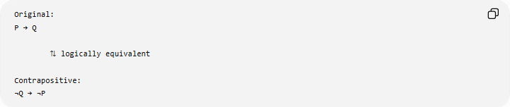
Original:
P → Q

⇅ logically equivalent

Contrapositive:
¬Q → ¬P
Another Geometric Example
Consider:
If a triangle is not equilateral, then its three angles are not all equal.
The contrapositive can be expressed as:
If all three angles of a triangle are equal, then the triangle is equilateral.
For a triangle:
$$A=B=C$$
Since:
$$A+B+C={180}^{∘}$$
we obtain:
$$3A={180}^{∘} \\ A=B=C={60}^{∘}$$
Equal angles in a triangle have equal opposite sides, so:
$$AB=BC=CA$$
Therefore, the triangle is equilateral.

5. Proof by Cases
# Source: AI Source: Provided by: [Data Path: Persons Table -> ID Column: 1, Name_En Column: Motasem Essam] -> From: [ChatGPT] on [7/25/2026]
Definition
Proof by Cases is a deductive method in which a problem is divided into two or more possible cases, and the required conclusion is established separately for each case.
The cases must collectively cover all relevant possibilities.
General Structure
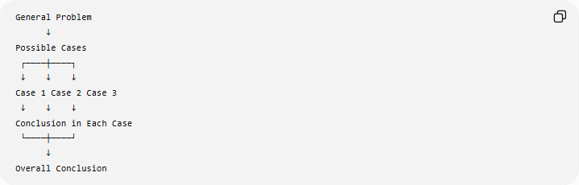
General Problem
↓
Possible Cases
┌────┼────┐
↓ ↓ ↓
Case 1 Case 2 Case 3
↓ ↓ ↓
Conclusion in Each Case
└────┼────┘
↓
Overall Conclusion
Example: Triangle Angle Classification
Consider a triangle. Every triangle falls into one of these angle classifications:
- acute,
- right,
- obtuse.
Suppose a geometric statement must be established for every triangle.
We can reason by cases:
Case 1: Acute Triangle
$$0^{∘}<A,B,C<{90}^{∘}$$
Prove the required relationship for the acute case.
Case 2: Right Triangle
One angle is:
$${90}^{∘}$$
Prove the relationship for the right-triangle case.
Case 3: Obtuse Triangle
One angle satisfies:
$${90}^{∘}<A<{180}^{∘}$$
Prove the relationship for the obtuse-triangle case.
Since every triangle belongs to one of these angle classifications, establishing the conclusion in every case establishes the conclusion for all triangles covered by the classification.

More Detailed Example of Proof by Cases
Suppose we want to determine the possible relationship between two lines based on their slopes.
For nonvertical lines, there are two relevant possibilities:
Case 1: Equal slopes
If:
$$m_{1}=m_{2}$$
then:
$$\boxed{l_{1}∥l_{2}}$$
provided the lines are distinct.
Case 2: Different slopes
If:
$$m_{1}≠m_{2}$$
then the lines are not parallel.
This is a simple example of dividing a problem according to mutually distinct possibilities.

Comparison of the Five Types
# Source: AI Source: Provided by: [Data Path: Persons Table -> ID Column: 1, Name_En Column: Motasem Essam] -> From: [ChatGPT] on [7/25/2026]
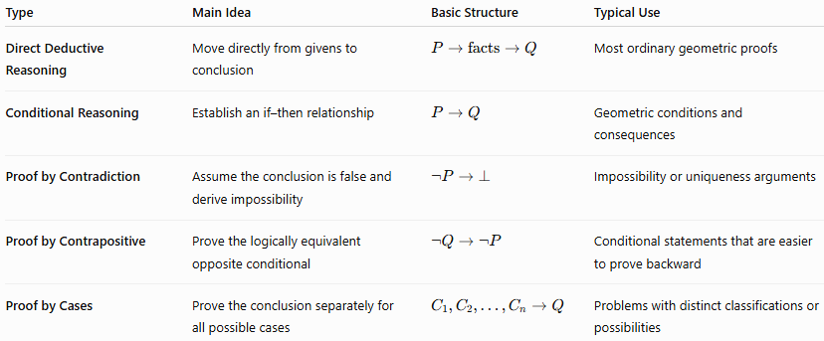
Type | Main Idea | Basic Structure | Typical Use
Direct Deductive Reasoning | Move directly from givens to conclusion | $$P→\text{facts}→Q$$ | Most ordinary geometric proofs
Conditional Reasoning | Establish an if–then relationship | $$P→Q$$ | Geometric conditions and consequences
Proof by Contradiction | Assume the conclusion is false and derive impossibility | $$¬P→⊥$$ | Impossibility or uniqueness arguments
Proof by Contrapositive | Prove the logically equivalent opposite conditional | $$¬Q→¬P$$ | Conditional statements that are easier to prove backward
Proof by Cases | Prove the conclusion separately for all possible cases | $$C_{1},C_{2},…,C_{n}→Q$$ | Problems with distinct classifications or possibilities

Important Distinction
# Source: AI Source: Provided by: [Data Path: Persons Table -> ID Column: 1, Name_En Column: Motasem Essam] -> From: [ChatGPT] on [7/25/2026]
These five methods should not be confused with the formats used to write a proof.
Logical Methods
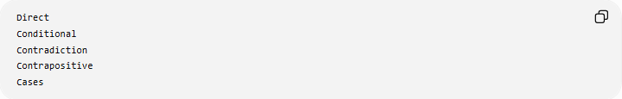
Direct
Conditional
Contradiction
Contrapositive
Cases
Proof Presentation Formats
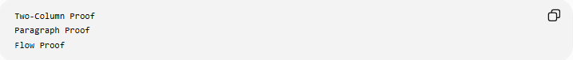
Two-Column Proof
Paragraph Proof
Flow Proof
For example, you can write a proof by contradiction using a two-column format.
Likewise, a direct proof can be presented as a paragraph proof.
Therefore:
$$\boxed{\text{Logical Method}≠\text{Proof Format}}$$

Relationship Between the Types
# Source: AI Source: Provided by: [Data Path: Persons Table -> ID Column: 1, Name_En Column: Motasem Essam] -> From: [ChatGPT] on [7/25/2026]
These methods are not completely isolated. They can work together.
For example:
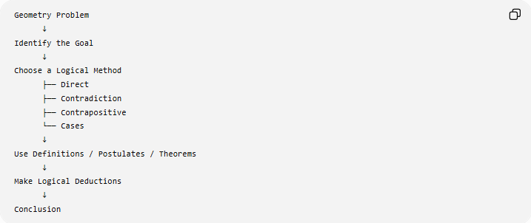
Geometry Problem
↓
Identify the Goal
↓
Choose a Logical Method
├── Direct
├── Contradiction
├── Contrapositive
└── Cases
↓
Use Definitions / Postulates / Theorems
↓
Make Logical Deductions
↓
Conclusion
Conditional reasoning is slightly different from the others because it describes the logical form of an implication:
$$P→Q$$
rather than always representing a completely separate proof strategy. A conditional statement can be proven directly, by contradiction, or through its contrapositive.

Deductive Reasoning Using Geometric Relationships
# Source: AI Source: Provided by: [Data Path: Persons Table -> ID Column: 1, Name_En Column: Motasem Essam] -> From: [ChatGPT] on [7/25/2026]
Many geometric proofs depend on relationships between angles, lines, and segments.

Vertical Angles
# Source: AI Source: Provided by: [Data Path: Persons Table -> ID Column: 1, Name_En Column: Motasem Essam] -> From: [ChatGPT] on [7/25/2026]
If two lines intersect, opposite angles are vertical angles.
Therefore:
$$\boxed{∠1=∠3}$$
and
$$\boxed{∠2=∠4}$$

Linear Pair
# Source: AI Source: Provided by: [Data Path: Persons Table -> ID Column: 1, Name_En Column: Motasem Essam] -> From: [ChatGPT] on [7/25/2026]
If two adjacent angles form a linear pair:
$$\boxed{∠1+∠2={180}^{∘}}$$

Complementary Angles
# Source: AI Source: Provided by: [Data Path: Persons Table -> ID Column: 1, Name_En Column: Motasem Essam] -> From: [ChatGPT] on [7/25/2026]
If two angles are complementary:
$$\boxed{A+B={90}^{∘}}$$

Supplementary Angles
# Source: AI Source: Provided by: [Data Path: Persons Table -> ID Column: 1, Name_En Column: Motasem Essam] -> From: [ChatGPT] on [7/25/2026]
If two angles are supplementary:
$$\boxed{A+B={180}^{∘}}$$

Triangle Angle Sum
# Source: AI Source: Provided by: [Data Path: Persons Table -> ID Column: 1, Name_En Column: Motasem Essam] -> From: [ChatGPT] on [7/25/2026]
For every triangle:
$$\boxed{A+B+C={180}^{∘}}$$
Thus, if
$$A={50}^{∘}, B={60}^{∘}$$
then:
$$C={180}^{∘}-{50}^{∘}-{60}^{∘} \\ \boxed{C={70}^{∘}}$$

Deductive Reasoning with Congruent Triangles
# Source: AI Source: Provided by: [Data Path: Persons Table -> ID Column: 1, Name_En Column: Motasem Essam] -> From: [ChatGPT] on [7/25/2026]
Triangle congruence is one of the major tools of geometric deduction.
Standard congruence criteria include:
$$\boxed{SSS} \\ \boxed{SAS} \\ \boxed{ASA} \\ \boxed{AAS} \\ \boxed{RHS/HL}$$
Once two triangles are proven congruent, corresponding parts are congruent.
This is expressed by CPCTC:
Corresponding Parts of Congruent Triangles are Congruent.
For example:
$$△ABC≅△DEF$$
allows conclusions such as:
$$AB=DE$$
and
$$∠A=∠D$$

Deductive Reasoning with Similar Triangles
# Source: AI Source: Provided by: [Data Path: Persons Table -> ID Column: 1, Name_En Column: Motasem Essam] -> From: [ChatGPT] on [7/25/2026]
Similar triangles allow geometric relationships to be established through proportionality.
If:
$$△ABC∼△DEF$$
then corresponding sides are proportional:
$$\boxed{\frac{AB}{DE}=\frac{BC}{EF}=\frac{AC}{DF}}$$
and corresponding angles are congruent.
This can be used to determine unknown lengths and establish geometric relationships.

Deductive Reasoning with Parallel Lines
# Source: AI Source: Provided by: [Data Path: Persons Table -> ID Column: 1, Name_En Column: Motasem Essam] -> From: [ChatGPT] on [7/25/2026]
When parallel lines are intersected by a transversal, several angle relationships can be used.
Corresponding Angles
$$\boxed{\text{Corresponding angles are congruent}}$$
Alternate Interior Angles
$$\boxed{\text{Alternate interior angles are congruent}}$$
Alternate Exterior Angles
$$\boxed{\text{Alternate exterior angles are congruent}}$$
Same-Side Interior Angles
$$\boxed{A+B={180}^{∘}}$$
These relationships allow one known angle to produce several additional conclusions.

Deductive Reasoning with Algebra
# Source: AI Source: Provided by: [Data Path: Persons Table -> ID Column: 1, Name_En Column: Motasem Essam] -> From: [ChatGPT] on [7/25/2026]
Geometry frequently combines geometric facts with algebraic reasoning.
Example
Suppose:
$$AB=3x+5$$
and
$$AB=2x+10$$
Since both expressions represent the same segment:
$$3x+5=2x+10$$
Subtract $2x$:
$$x+5=10$$
Subtract $5$:
$$\boxed{x=5}$$
The geometric relationship supplies the equation, and algebraic deduction determines the unknown.

Coordinate Deductive Reasoning
# Source: AI Source: Provided by: [Data Path: Persons Table -> ID Column: 1, Name_En Column: Motasem Essam] -> From: [ChatGPT] on [7/25/2026]
Coordinate geometry uses algebraic calculations to establish geometric properties.
Distance
For
$$A\left(x_{1} , y_{1}\right), B\left(x_{2} , y_{2}\right)$$
the distance is:
$$\boxed{AB=\sqrt{{\left(x_{2}-x_{1}\right)}^{2}+{\left(y_{2}-y_{1}\right)}^{2}}}$$
This can prove that two segments are congruent.
Midpoint
$$\boxed{M=\left(\frac{x_{1}+x_{2}}{2} , \frac{y_{1}+y_{2}}{2}\right)}$$
This can prove that a point bisects a segment.
Slope
$$\boxed{m=\frac{y_{2}-y_{1}}{x_{2}-x_{1}}}$$
Slope can establish:
$$m_{1}=m_{2}⇒\text{parallel}$$
and, for nonvertical lines,
$$m_{1}m_{2}=-1⇒\text{perpendicular}$$
Thus, coordinate calculations can serve as deductive evidence within a formal proof.

Deductive Reasoning with Transformations
# Source: AI Source: Provided by: [Data Path: Persons Table -> ID Column: 1, Name_En Column: Motasem Essam] -> From: [ChatGPT] on [7/25/2026]
Geometric transformations can also establish relationships.
Isometry
An isometry preserves distance:
$$\boxed{d\left(T , \left(P\right)T\left(Q\right)\right)=d\left(P , Q\right)}$$
Therefore, a transformation such as a reflection, rotation, translation, or glide reflection can be used to establish congruence.
Similarity Transformation
A similarity transformation scales distances by a constant factor $k$:
$$\boxed{d\left(T , \left(P\right)T\left(Q\right)\right)=k d\left(P , Q\right)}$$
Therefore, it can be used to establish similarity.

Deductive Reasoning with Loci
# Source: AI Source: Provided by: [Data Path: Persons Table -> ID Column: 1, Name_En Column: Motasem Essam] -> From: [ChatGPT] on [7/25/2026]
A locus is the set of all points satisfying a specified geometric condition.
For example, the locus of points equidistant from $A$and $B$is the perpendicular bisector of $\overset{‾}{AB}$.
$$PA=PB$$
implies:
$$\boxed{P\text{ lies on the perpendicular bisector of }AB}$$
This provides a powerful deductive connection between a condition and a geometric location.

Deductive Reasoning vs. Inductive Reasoning
# Source: AI Source: Provided by: [Data Path: Persons Table -> ID Column: 1, Name_En Column: Motasem Essam] -> From: [ChatGPT] on [7/25/2026]
These two forms of reasoning should be distinguished.
Feature | Deductive Reasoning | Inductive Reasoning
Direction | General → specific | Specific → general
Starting point | Accepted facts/rules | Observations/examples
Conclusion | Necessarily true if reasoning is valid | Generalization based on evidence
Main purpose | Proof | Conjecture/pattern discovery
Example | Theorem → specific triangle | Several examples → suspected pattern
Example
Suppose several triangles are measured and all appear to have an angle sum of ${180}^{∘}$.
That observation is inductive reasoning.
Using the Triangle Sum Theorem to prove that a particular triangle has angle sum ${180}^{∘}$is deductive reasoning.

Deductive Reasoning vs. Visual Reasoning
# Source: AI Source: Provided by: [Data Path: Persons Table -> ID Column: 1, Name_En Column: Motasem Essam] -> From: [ChatGPT] on [7/25/2026]
A diagram can help identify relationships, but appearance alone is not proof.
For example, a diagram may appear to show:
$$AB=BC$$
However, unless this equality is:
- given,
- constructed,
- measured under an appropriate assumption,
- or logically established,
it cannot simply be assumed from appearance.
Therefore:
$$\boxed{\text{Visual Appearance}≠\text{Deductive Proof}}$$

Deductive Reasoning vs. Measurement
# Source: AI Source: Provided by: [Data Path: Persons Table -> ID Column: 1, Name_En Column: Motasem Essam] -> From: [ChatGPT] on [7/25/2026]
Measurement can provide numerical evidence.
For example, measuring two angles may give:
$${59.9}^{∘} \text{and} {60.1}^{∘}$$
This suggests that the angles might be equal, but measurement precision does not establish exact equality.
Deductive reasoning instead derives:
$$\boxed{∠A=∠B}$$
from established geometric facts.

Geometry Deductive Reasoning Framework
# Source: AI Source: Provided by: [Data Path: Persons Table -> ID Column: 1, Name_En Column: Motasem Essam] -> From: [ChatGPT] on [7/25/2026]
A useful general framework is:
Geometry Deductive Reasoning
│
├── 1. Identify the Given Information
│
├── 2. Identify the Required Conclusion
│
├── 3. Identify Relevant Definitions
│
├── 4. Identify Applicable Postulates
│
├── 5. Identify Applicable Theorems
│
├── 6. Apply Logical Rules
│
├── 7. Derive Intermediate Results
│
├── 8. Connect Results to the Goal
│
└── 9. State the Conclusion

Complete Example
# Source: AI Source: Provided by: [Data Path: Persons Table -> ID Column: 1, Name_En Column: Motasem Essam] -> From: [ChatGPT] on [7/25/2026]
Given
In $△ABC$:
$$AB=AC$$
Prove
$$∠B=∠C$$
Deductive Reasoning
Statement | Reason
$$AB=AC$$ | Given
$△ABC$is isosceles | Definition of isosceles triangle
$$∠B=∠C$$ | Isosceles Triangle Theorem
Therefore:
$$\boxed{∠B=∠C}$$
The conclusion is not based on how the triangle looks. It follows necessarily from the given equality and the theorem.

Classification
# Source: AI Source: Provided by: [Data Path: Persons Table -> ID Column: 1, Name_En Column: Motasem Essam] -> From: [ChatGPT] on [7/25/2026]
By Logical Method
Geometry Deductive Reasoning
├── Direct Reasoning
├── Conditional Reasoning
├── Proof by Contradiction
├── Proof by Contrapositive
└── Proof by Cases
By Geometric Framework
Geometry Deductive Reasoning
├── Definition-Based
├── Axiom-Based
├── Postulate-Based
├── Theorem-Based
├── Angle-Based
├── Congruence-Based
├── Similarity-Based
├── Algebraic
├── Coordinate-Based
├── Transformation-Based
├── Locus-Based
└── Symmetry-Based
These classifications overlap. A single proof may be, for example, a direct deductive proof using triangle congruence and algebra.

Key Characteristics
# Source: AI Source: Provided by: [Data Path: Persons Table -> ID Column: 1, Name_En Column: Motasem Essam] -> From: [ChatGPT] on [7/25/2026]
- It uses known information as a starting point.
- Every conclusion must follow from valid reasoning.
- Definitions, axioms, postulates, and theorems provide the mathematical foundation.
- Intermediate conclusions can become the basis for later deductions.
- It establishes necessity, not merely likelihood.
- Diagrams help visualize the problem but do not replace logical justification.
- Measurement can provide evidence but does not generally replace proof.
- Deductive reasoning is the foundation of formal geometric proofs.
- Different logical methods can be combined within one proof.
- A valid deductive proof establishes the conclusion for all cases satisfying its assumptions, not merely for one diagram.

Relationship to Geometry Logical Proofs
# Source: AI Source: Provided by: [Data Path: Persons Table -> ID Column: 1, Name_En Column: Motasem Essam] -> From: [ChatGPT] on [7/25/2026]
The concepts are closely related:
$$\boxed{\text{Deductive Reasoning}→\text{Logical Proof}}$$
Deductive reasoning is the logical process used to derive necessary conclusions.
Geometry logical proof is the formal mathematical argument that presents those deductions to establish a geometric statement.
Therefore:
Geometry
↓
Geometric Facts
↓
Deductive Reasoning
↓
Logical Proof
↓
Established Geometric Conclusion

Conclusion
# Source: AI Source: Provided by: [Data Path: Persons Table -> ID Column: 1, Name_En Column: Motasem Essam] -> From: [ChatGPT] on [7/25/2026]
Geometry Deductive Reasoning is the logical process of deriving necessary geometric conclusions from given information and established mathematical principles. It connects definitions, axioms, postulates, theorems, geometric relationships, and logical rules into a chain of valid deductions.
$$\boxed{\text{Given}→\text{Known Principles}→\text{Logical Deductions}→\text{Conclusion}}$$
It is therefore the fundamental reasoning process behind formal geometry proofs: rather than concluding that a statement is true because it looks true or works in an example, deductive reasoning establishes why it must be true.

